CHAPTER 12

Boroughbridge to Darlington via Scotch Corner

We left the town of Boroughbridge by way of Dishforth and Topcliffe, but another variant, which was eventually to become the main route, followed the Roman road to Catterick and Scotch Corner. In the coaching days, the Glasgow Mail and the Express London to Carlisle coach were amongst those that went this way. The road to Scotch Corner is 26 ½ miles and almost straight for the whole distance. This road parted from the older road on the northern side of the Ure at what is now a roundabout and went through the small village of Kirby Hill to just south of RAF Dishforth, where it rejoins the main A1, now the last mile or so of motorway. The motorway, completed in 1996, replaced the older bypass, like so many planned in the 1930s but not built until 40 years later. The road passes to the west of the former RAF station, now a base for the Army Air Corps, and the Teesside road forks off to the right just to the north.

From the A168 junction just west of Dishforth, where the last roundabout on the A1 in Yorkshire was removed in October 1989, the road runs dead straight and nearly level along Leeming Lane to Londonderry. For much of the way the tall and elegant spire of St James's Church, Baldersby, built like much of the village it serves in 1858 by William Butterfield, is visible to the east of the road; the bells were too heavy for the tower, which swayed when they were rung full circle, but in 2000 an electro-magnetic computerised system was installed, which allowed them to be heard properly for the first time in 100 years. This straight, level stretch was widely used for sporting matches in the days of horses and later in the early motoring years. Just after the Baldersby flyover, until 1987 another roundabout, where the A61 Ripon to Thirsk road crosses, there stands a derelict farmhouse, York Gate Farm, which was an inn in coaching times. In 1946, the Ministry of Transport reported:

The widening of a seven mile stretch of narrow road, to provide dual carriageways, cycle tracks and footpaths, was in hand at the outbreak of war, but work was stopped when about three miles of one of the new carriageways had been completed, including the elimination of the level crossing at Baldersby and the construction of a new bridge over the London and North Eastern Railway at Sinderby, wide enough to carry a single carriageway and footpath.

It was not until 1958 that this work was completed, including a flyover across the B6267 Thirsk-Masham road.

Between the turning to Pickhill on the right and that to Burneston on the left are the remains of two coaching inns, both now private dwellings. The first, on the right is New Inn Farm, where the Mails and the Telegraph (Leeds and Newcastle) were horsed. The second, on the other side, is the Old Oak Tree, now Oaktree House, where the Red Rover and its successor, the Joint Stock, both Leeds to Newcastle coaches and competitors of the Telegraph, were changed. The Red Rover was first run in 1833 in direct competition with the Telegraph and survived only 12 months, but the Joint Stock kept going until 1842; the Telegraph outlived them both, being competitive both in terms of speed and of price. To the west of the road is the spire of Saint Lambert's Church, Burneston, one rector of which, the Revd J T Hartley, was Wimbledon men's champion in 1879 and 1880; it is said that he travelled home during the tournament to take his services in the church. At Gatenby soon after this a new flyover and junction was built in 1992 for the RAF station at Leeming.

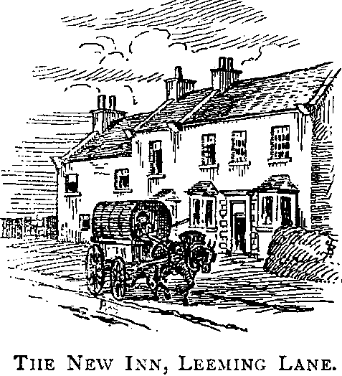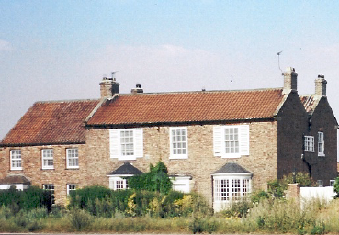
Inns on Leeming Lane. Above, the New Inn drawn by Bradley in the 1880s and, recently, as a private house. It is likely to be demolished soon to allow the road to be upgraded. Below, Oak Tree House, formerly the Old Oak Inn.

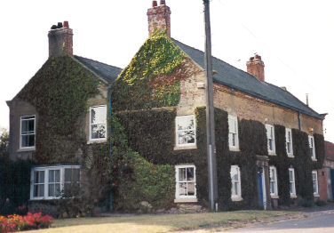
At Londonderry, the Leeming Bar bypass swings away to the west, but the old road continues straight past RAF Leeming, originally a civil airfield, acquired by the Air Ministry in 1938 and opened as a bomber base in June 1940. It is now home to three squadrons of Tornados. The road goes into Leeming village and, after a sharp bend where the road crosses the Bedale Beck, arrives at Leeming Bar, where there was a turnpike gate and, later, a level crossing. Old and new roads meet again to the north of the village and the A1 continues along a ridge giving fine views to the west, with Pen Hill above Wensleydale prominent on the skyline. On the right is RAF Catterick, opened as an airfield for the Royal Flying Corps between the Wars, modernised as an RAF station in 1935, until recently home to the RAF Regiment, and now an army camp again under the name of Marne Barracks. Yet another bypass, opened in 1959, takes the A1 to the west while the old coach road went through Catterick Village. There the rival coaches changed horses at adjacent inns, the Telegraph at the Angel and the Red Rover and Joint Stock at the Golden Lion, where the landlord's daughter married a coachman, Joe Scott, who took on the inn himself in due course.

The George at Catterick Bridge, now called the Bridge House Hotel, changed the Mails and the Express and carried on the posting trade. This inn lies about a mile north of the village, by the racecourse, where the road crosses the Swale, supposedly the fastest flowing river in England. The Roman city was just to the west of the bridge, south of the river. Thoresby was here 300 years ago and reported:

We passed the river Swale, (which our predecessors reputed sacred, for Paulinius's baptizing therein ten thousand men in one day, when the English-Saxons first embraced Christianity) at Catterick, so called from the catadupa, a little above this small town......a famous city in the Roman times, being their Cataractonium, and eminent amongst the Saxons, King Ethelred solemnizing here his marriage with King Offa's daughter; but it was burnt, A.D. 769, by Eanred.

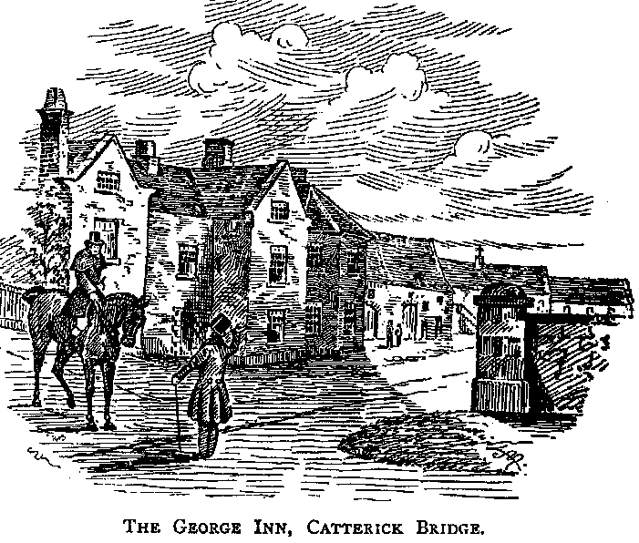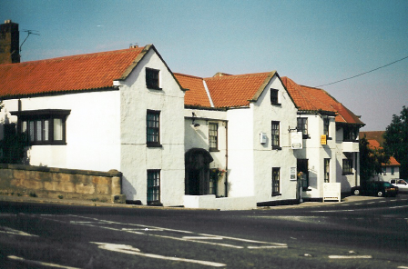
Catterick Bridge, where the Great North Road crosses the Swale. The inn here was called the George in coaching days, but is nowadays known as the Bridge Hotel.

The bridge here dates from 1422 and the contract to build a new stone bridge "betwixt ye olde stone brigg and ye new brigg of trees" can be seen in the North Yorkshire County Archives. It was on this bridge, by then much altered, that John Ruskin had a youthful emotional experience, as he tells us in his unfinished autobiography:

On the journey of 1837, when I was 18, I felt, for the last time, the pure childish love of nature which Wordsworth so idly takes for an intimation of immortality. We went down by the North Road, as usual; and on the fourth day arrived at Catterick Bridge, where there is a clear pebble-bedded stream, and both west and east some rising of hills, foretelling the moorlands and dells of upland Yorkshire; and there the feeling came back to me - as it could never return more.

At the George, which lies directly opposite the racecourse, Daniel Ferguson was Mine Host for 40 years in the days of coaching. Racegoers and cockfighters gathered here. The Salutation, which has now disappeared, was also well known for the cockings, then perfectly legal.

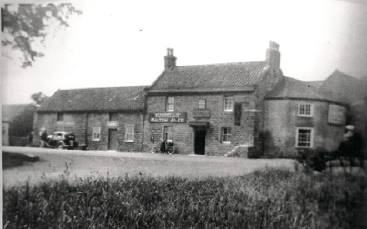
Scotch Corner. The Three Tuns, above, was demolished in 1938 to make room for a roundabout at the junction of the Penrith road. It was replaced by the Scotch Corner Hotel, built a little further back. The flyover was built in 1971, leaving the hotel well set back from the main road.

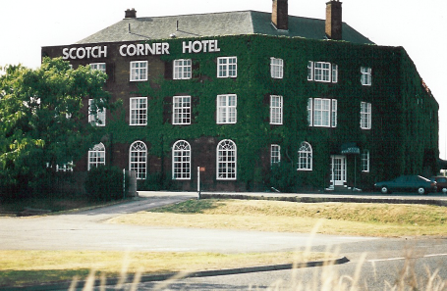

The road continues due north, rejoining the 1959 bypass, to the fork known as Scotch Corner. Here the Penrith and Carlisle road turns off to go past Greta Bridge, the scene of Dotheboys Hall in Nicholas Nickleby, and over Bowes Moor and the Pennines. There is now a hotel at the junction built in 1938 on the site of the demolished Three Tuns, which was compulsorily acquired by the Ministry of Transport to make room for a roundabout. This was named the Scotch Corner Hotel and was a military hospital during the 1939-45 War. Since 1971 the A1 has run to the east of and below the hotel under the flyover. About a mile farther on, our road leaves the line of Dere Street, which itself continued straight through Piercebridge to Bishop Auckland, and just before the start of another section of A1(M) motorway, runs northeast to cross the river Tees at Blackwell Bridge and thus into Darlington.

This stretch of motorway, which we shall not follow in detail, was built on an entirely new route in the 1960s, starting in the south with the Darlington bypass (approved in 1950 but not opened until 1965) and ending with the Birtley bypass and the spur towards the Tyne Tunnel which is now the A194(M) (opened in 1970), and runs through the entire county of Durham to the southern outskirts of Gateshead. It crosses the old Great North Road just to the north of Darlington and then runs to its east until they meet again near the Tyne. The prospect of building a new motorway such as this, over virgin countryside, in today's conditions is unthinkable.

From Scotch Corner to Darlington the road was substantially improved in the mid 1920s. A newspaper report in 1926 articulated some worries that have a contemporary ring.

The branch road to Darlington from Scotch Corner was never constructed to take the huge volume of traffic it has to carry in these days. It was a five-mile stretch of road of narrow width over undulating country, watercourses crossed by narrow bridges, and with as many bends as a spiralling spring.....Complaint has been made of the destruction of the natural beauty surrounding the old road. The new road, as so far constructed, is more practical than picturesque. In the reconstruction work the contractors have of necessity had to fell hedgeside timber in order to widen the road. It would be impossible to make a safe road and leave trees standing which in the past interfered with visibility. Existing hedgerows, too, have been torn out, but a road fencing is being erected of a double row of posts and rails enclosing hawthorn shrubs which, in a few years, will perform the dual purpose of preventing cattle from breaking through and lending natural beauty to the landscape.

Here is the Ministry of Transport's rather more prosaic report on completion of the work:

Approximately 4½ miles of this road from Scotch Corner to Stapleton, within the North Riding of Yorkshire, have been widened, reconstructed and resurfaced. Gradients have been improved, and numerous switchbacks have given place to regular and economical gradients. The road generally has been widened to 60ft. between fences, the carriageway being 20ft. Two new reinforced concrete bridges have been constructed and the existing masonry arch bridge at Barton has been widened to suit the new conditions.

The route through Barton and Stapleton and over Blackwell Bridge was the main road for most of the motoring era, until the A1(M) was built and Darlington bypassed, and it was in earlier times too, as the tollhouse on the bridge approach witnesses. Which precise route was taken here, as elsewhere, probably depended on the weather. Ralph Thoresby reports, in 1703: "The river Tees not being fordable by reason of the late rains, we went about by Croft bridge, where Sir William Chater has a seat." Celia Fiennes, heading for Richmond, also seems to have missed Blackwell Bridge, for she reports that, after leaving Darlington and Hell's Kettles, she

... passed over Crafton Bridge which crosses the river Teess, and soe entered the North Rideing of Yorkshire in which is that they call Richmondshire a shire of 30 miles; the way was good but long, I went through lanes and woods an enclosed country, I passed by a houes of Sir Mark Melborn on a hill, a brick building severall towers on the top, good gardens and severall rows of trees up to the house, it standing on a hill the trees runns along on the ridge of the same looks very finely.

The house on the hill was Halnaby Hall, now demolished - though its fine gatehouses survive - where Byron spent his honeymoon with Annabella Milbanke.

Report on the Administration of the Road Fund 1945-46.
Ralph Thoresby Diary 27 September 1694.
John Ruskin 1819-1900 Praeterita.
The Times 25 January 1926.
Report on the Administration of the Road Fund 1927-28.
Ralph Thoresby Diary 21 May 1703. He made frequent journeys to the north and seems to have taken various routes on different occasions. The Chaytor family still live at Croft.
See Part II Chapter 11.
Fiennes pp 180-1.
See Part II Chapter 11.

