CHAPTER 10

Brotherton to Northallerton

Those coaches which did not turn off for York via Sherburn turned left into Brotherton and continued along the route of the modern A1 through the now divided village of Fairburn, past Selby Fork, where the Leeds to Selby road leaves the Great North Road, to Peckfield Bar, where the Boot and Shoe Inn still stands, and where the A63 forks off to the left. Here coaches for Leeds, such as the Rockingham, the Union Post and of course the Royal Mail turned off. The road went on through Micklefield, once a mining village, to Hook Moor, where the Roman road, Dere Street, coming up from Castleford, rejoins it. Hook Moor has become better known in the mid 1990s as it is here that the Lofthouse-Bramham M1/A1 link road, built under a Design, Build, Finance and Operate scheme by private sector companies, emerges. The eight lane road from here to the Bramham Cross Roads is part of the same scheme and has been upgraded to motorway. There are also plans in hand to upgrade the section from Darrington to Hook Moor, currently one of the most dangerous on the whole length of the road, to six lane motorway, which will divert the route away from Brotherton and Fairburn.

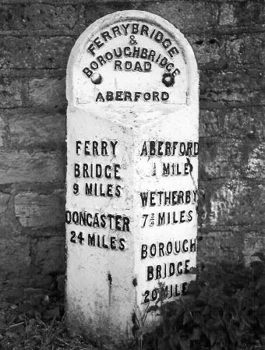
Milestone just south of Aberford.

The old Great North road followed the Roman line through Aberford, passing the gates of Parlington Park, former home of the ancient Gascoigne family, who in 1844 built the gothic almshouses (which can also be seen from the bypass, first built in 1963 but now much enlarged and improved) and descends into the village, once an important post on the Road, through a 19th Century cutting. Leland wrote, in the middle of the 16th Century: "To the east of Aberford survive two or three long ditches which have the appearance of military earthworks. In no other part of England have I seen such obvious remains as here of the massive man-made embankment on which Watling Street (sic) runs." The Iron Age earthworks mentioned are what remains of The Rein, an ancient road running in a south easterly direction towards Sherburn in Elmet, but similar remains lie to the west of the village at Becca Banks. Aberford was, according to Defoe, a centre of pin-making. The Up Glasgow and Carlisle Mails changed at the Swan, which is still there; but most coaches did the 17 mile Ferrybridge to Wetherby stage as one.

Just outside the churchyard there is an old market cross, said to include a Plague Stone, similar to that in Retford, the purpose of which was to immerse coins in a mixture of water and vinegar to sterilise them. But it is impossible to see where the bowl was, as the cross is much eroded; what can be seen is the inscription recording that the cross was taken down in 1644 during the plague and re-erected by public subscription in 1911 to celebrate King George V's coronation. The church, incidentally, is dedicated to Saint Ricarius. Celia Fiennes did not think much of the people hereabouts, for she was in Aberford when she wrote:

I observe the ordinary people both in these parts of Yorkshire and in the northern parts can scarce tell you how farre it is to the next place unless it be in the great towns and there in their publick houses; and they tell you its very good gate [gait], instead of saying it is a good way, and they call their gates yates, and do not esteem it uphill unless so steep as a house or precipice; they say its good levell gate all along, when it may be there are severall great hills to pass, ......but in generall they live much at home and scarce ever go 2 or 10 mile from thence, especially the women, so may be term'd good housekeepers.

As the road climbs away from Aberford, the line of the Roman road diverges to the east running beside the woods surrounding Hazlewood Castle. Two miles farther on, the motorway ends where the A64 Leeds to Scarborough road crosses. Although there has been a flyover herefor nearly 40 years, the locals still know the junction as the Bramham Cross Roads. When Harper wrote, in 1922, the Bramham Moor Inn still stood there and he was able to say that "....a considerable traffic enlivened the way until eighty years ago. Since that time the broad roadways in either direction have been empty, except when the hounds meet here in the hunting season, when, for a brief hour, old times seem come again." The crossroads today is as busy as anywhere on the A1. Until the first flyover was built in 1963, there were traffic lights at the junction, which caused huge traffic jams, especially at summer weekends when the population of Leeds and its environs went to the seaside at Scarborough.

The road continues past the site of the Battle of Bramham Moor (1408) and originally went through the village of Bramham, which has been bypassed twice in recent times, the latest being when the section of six lane dual carriageway was built in 1992. Bramham Park, off to the left, was a ruin when Harper wrote in 1901, having been severely damaged by fire in 1828 and unoccupied for nearly 80 years, but it was restored between 1906 and 1914 and is the home of Major George Lane Fox, whose ancestor and namesake was a famous gentleman coachman on the Great North Road. Pevsner had this to say about the house and its setting:

If ever house and gardens must be regarded as one ensemble, it is here. Bramham is a grand and unusual house, but its gardens are grander and even more unusual. They are with Hampton Court and perhaps one or two others the most remarkable example in England of the planning of a park in the French manner of Louis XIV. There must have been many more of this type in the early C18, but the vigour of the Picturesque Movement swept them away and replaced their canals by serpentine lakes and their avenues and long vistas by winding drives and walks.

Visitors today can be thankful that Capability Brown did not improve the landscape for the garden contains some magnificent beech hedges, which unlike many fine old trees in the park escaped the gale of February 1962. The park is the scene of a three day equestrian event in June.

The road first rises then descends from there to Wetherby, where three bridges side by side cross the River Wharfe. In 1822, Paterson's guide said that "The river forms a very fine cascade, a little above the bridge, by falling over a dam that has been constructed for the convenience of the mills, and the salmon in their progress from the sea up the river, are frequently seen to leap over this cascade with admirable dexterity." The town was bypassed first in 1959, which caused an immediate drop in traffic from 685 vehicles per hour to 159. Initially the York Road crossed the bypass in a cross-roads until the present flyover was built in 1962. A further bypass was built in 1988 to avoid the roundabout at the southern end, which had become a huge bottleneck for traffic travelling north especially on Friday evenings; this new bridge was obsolescent as soon as it was finished as it can carry only two lanes of traffic in each direction, one fewer than now needed. As a result of the Government's decision in 1996 to reduce expenditure on road improvement schemes, the plan to link the six lane section from Bramham to Wetherby with the motorway from Walshford to Dishforth, was abandoned, leaving three miles of rather old-fashioned four lane dual carriageway between, though in early 1997, in another apparent change of mind, the Government said that the Wetherby to Walshford section - though not the Wharfe bridge - would after all be upgraded after 2000.

Wetherby has the unusual distinction for a market town of having been put up for sale. In 1824, the Duke of Devonshire, whose family had owned the town since 1678, sold out at auction. The estate was sold piecemeal and fetched a total of £168,561.

To the east of the road on the approach to the town was Wetherby Grange, also previously known as Beilby Grange, the home, in Byng's time, of the Thompsons. "I rode to Mr Thompson's, Wetherby Grange, whose grand Beauty is the (conceal'd) Wharf. The grounds are idly neglected." It was later owned by the Gunter family, whose fortune was made at Gunter's Tea Shop in Berkeley Square, and later in Curzon Street. Sir Robert Gunter, created a baronet in 1901, was the son of the pastry-cook and made another fortune developing land his father had bought in Earl's Court, where Wetherby Gardens, Bramham Gardens, Collingham Road and Wharfedale Street all witness his love of this part of Yorkshire. The house was demolished in 1962, but the park lies behind the wall to the east of the road and is used for sports pitches and other recreational activities. A former gatehouse stands, rather forlornly, on the roundabout under the flyover at the junction with the A659 Otley to Tadcaster road a mile south of Wetherby.

An elegant stone screen by the roundabout at the south of the town hides the police station and magistrates’ court. The old road enters the town over the stone bridge. Coaches changed at the Swan and Talbot or the Angel and, after 1824, exclusively at the latter, which was run by the Cleminsons, father and son, who owned 100 horses, keeping them in various stables nearby, including Angel Court. They had a sign on the front claiming, with a degree of artistic licence, to be the half way house between London and Edinburgh. Here the passengers on the Down Glasgow Mail had an hour to dine; they had left London at 8 pm the previous evening. Byng stayed here in 1792, and rather uncharacteristically, seems to have been content: "This Angel Inn at Wetherby I should highly recommend for its civility, cheapness and good cookery. They take in both the morning and evening papers, which become a wonderful treat at this distance from London." The Swan and Talbot reverted to serving the posting business once the Angel had established a monopoly of coaching.

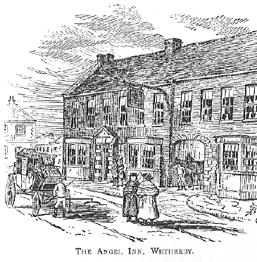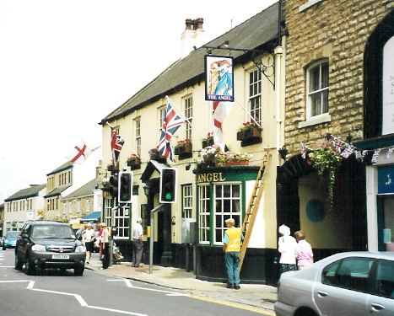
The Angel, Wetherby, drawn by Bradley and in a recent photograph. Part of the building has been rebuilt ias a three storied shop and is no longer part of the Inn.

Just north of the Swan and Talbot the road narrowed and turned sharp right and left in two right angles. The stretch from the bend to Horse Fair was said to be the narrowest on the Great North Road until 1929 when the Bowling Green Inn was demolished and the road widened and straightened.

To the north of Wetherby the old road rejoins the bypass. Just north of this junction once stood the Old Fox Inn, descibed by Bradley: "Exactly midway between London and Edinburgh, and a mile out of Wetherby on the road to the north, there still stands the Old Fox Inn, a house that was well known in the old coaching days, although it had no immediate connection with coaching." There was a milestone immediately outside it, but that has now disappeared. The drovers stopped for a drink here, though there was no land or accommodation so they could not stay, moving on to the Spotted Ox, also called the Drovers' Inn, south of Wetherby bridge, where the cattle were watered in the river and grazed in the fields. The Fox Inn is marked on old maps, just north of Loshpot Lane and south of Deighton Grange, but now seems to have become, like so many old inns, a farmhouse.

The road crosses the River Nidd at Walshford Bridge, on a modern structure, by the gates of Ribston Hall, a late 17th century house, fifteen bays wide. This was the birthplace of the Ribston Pippin, a dessert apple. The old bridge was replaced some years ago. It is now proposed, as part of the scheme to improve the three mile stretch of four lane road, to build a new bridge over the Nidd 400 yards to the east. The Bridge Inn, now seen from the east but passed on the west before road improvements, was a well known stop for motorists and before that a posting house. Until the road was improved, there was a sharp left hand bend just after the Inn. A little farther on begins the latest stretch of road to be brought up to motorway standard.

In the railway age, the Harrogate to York railway line crossed the road at Hopperton Station in a level crossing. To the left of the road still lies a farmhouse which was once the New Inn, Allerton, where the mails changed horses and the drovers stopped; this looks now much as it did in the 1920s, in spite of the road improvements around it. To the right just after the A59 is crossed can be seen the park wall, a restored classical rotunda and the upper stories of Allerton Park, home of the Mauleverers for centuries and to George III's brother, the Duke of York for 20 years until it was bought by the Roman Catholic Stourton family in 1805. They enlarged the house in the 1840s in Gothic Revival style and the interior was used for a film of The Secret Garden. Some people pronounce it Ollerton and it is said that a 19th Century Stourton, Lord Mowbray, the inheritor of one of the most ancient titles in the land, decided on that pronunciation to distinguish his estate when a Leeds tailor called Jackson who had made money and become an MP was raised to the peerage as Lord Allerton, taking his title from a Leeds suburb.

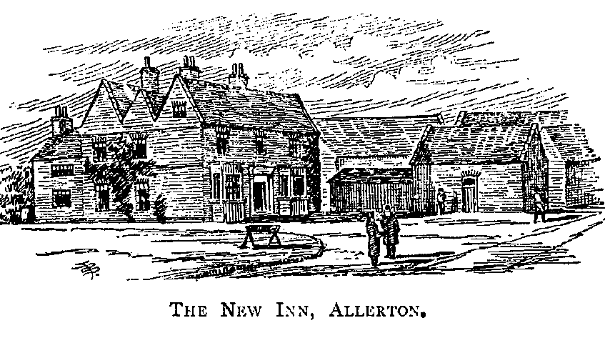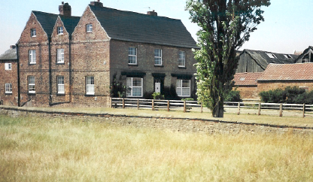
New Inn, Allerton, where some Mails changed horses in the coaching age. The present day farmhouse is little changed, except for the huge poplar.

Both Harper and Webster mention the hill of Nineveh, just north of here, but there seems no sign of it today. Here is Harper:

Now on the right comes the long wall of Allerton Park, and presently there rises ahead that strange mound known by the equally strange name of Nineveh, a tree-crowned hill, partly artificial, girdled with prehistoric earthworks, and honey-combed with the graves of the forgotten tribes, to whom it was probably at once a castle, a temple, and a cemetery

Harper has a drawing of the hill, which sheds little light, except that it seems to be by a road junction and this bears out Webster's assertion that it is by the corner of a tiny lane leading to the Ouseburns. Although the Ordnance Survey map suggests that Nineveh is north of that point, Webster's lane must be that by Claro Farm, which is now used as an entrance to the quarry behind and it may be that Nineveh is now part of the topsoil heap that is piled up there.

The new motorway runs to the west of the old A1, which still exists as a service road, to Boroughbridge, crossing the A6055 Boroughbridge to Knaresborough road just to the south of the town; this was the first road that Blind Jack Metcalf made in the 18th Century and up this road came the coaches from Leeds to the north, making it a busy junction. Boroughbridge stands next to the Roman settlement of Aldborough or Isurium and here we meet again the Roman road that we last saw at Aberford. This was a busy place and an important stage in the coaching era, with two main inns, the Crown and the Greyhounds opposite each other. The Crown, owned by the local landowners, the Tancred family, had huge stables and horsed most of the coaches and all the Mails. In the late 18th Century the tenant was one Fretwell, whose daughter married Dr Hugh Stott, who practised medicine as well as running the inn for nearly 50 years. The Greyhounds, originally called the Mauleverer Arms, had smaller stables and horsed fewer coaches. The arms of the Mauleverer family include three greyhounds courant and these can be seen in the plaster on the outside of the old building. The building now houses some shops; a plaque on its wall tells us that one tailor's shop here was occupied by the family of Captain Archie White VC MC who lived from 1890 to 1971. He won his VC while serving with 6th Bn The Yorkshire Regiment at the Somme in 1916.

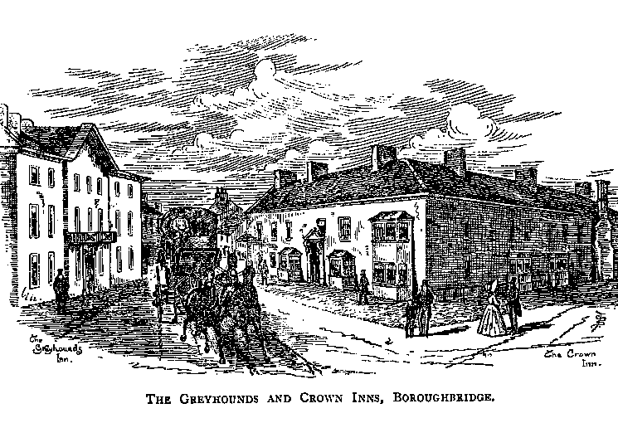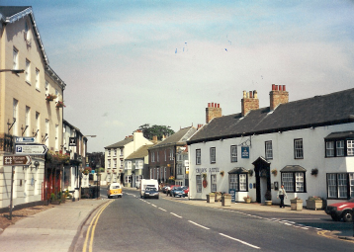
Boroughbridge by Bradley, showing the two main inns, the Crown to the right of the picture and the Greyhounds to the left, neither much changed in 120 years.

The motorway passes to the west of the town and also to the west of the 1963 bypass, which it has replaced. The main road into Boroughbridge from the south is called Horsefair and the Barnaby Fair was held there in June for centuries; the earliest recorded fair was in 1310 and a charter was granted in 1671. The horse fair continued to be held just outside the town until the 1980s when rowdyism caused it to be discontinued. Celia Fiennes came here in 1698 and reported: "Burrough Bridge a famous place for Salmon, but then we could not meete with any but we had a very large Codfish there, above a yard long and more than halfe a yard in compass very fresh and good and cost but 8 pence." Daniel Defoe also visited, commenting on the anomalies in representation that existed before the Reform Act of 1832: "There is something very singular at this town, and which is not to be found in any other part of England or Scotland, namely, two borough towns in one parish, and each sending two members to Parliament, that is Borough Brigg and Aldborough."

Boroughbridge is also famous for the Three Arrows, originally four, which stand between the new motorway and the town, just south of the river. Sometimes called the Devil's Arrows, they are prehistoric monoliths, considered ancient by the Romans, arranged in a straight line and standing about 20 feet above the ground. Thoresby mentions them:

Walked into the fields at Burrow-bridge to see the celebrated Roman Obelisks, commonly called the Devil's arrows; that which I measured was about three fathoms round, rather more, and perhaps eight or nine yards high: a second is about the same dimensions; a third not so tall but much thicker: the fourth is broke, and removed for a foot bridge, somewhere about the town.

The Arrows are of millstone grit, the nearest outcrop of which is at Knaresborough, six miles away.

The road leaves the town over the River Ure where, according to Thoresby, "There is now a good stone bridge, where in Edward II's time was one of wood, through a chink of which Bohan, Earl of Hereford, was thrust through with a spear by a soldier, who lay in ambush under the bridge." This was at the Battle of Boroughbridge in 1322, when the royal forces under Sir Andrew Harcla defeated the rebels under the Earls of Hereford and Lancaster. The scene of Hereford's death was the 12th Century bridge, which replaced the Roman crossing at Milby, half a mile downstream. Thoresby’s stone bridge was originally built in 1562 and improved by Metcalf in 1784. On 5th July 1945, this bridge was badly damaged by an 85 ton casting being carried from Sheffield to Falkirk on a 50 ton low loader propelled by front and back tractors each weighing 26 tons, making a total weight of 187 tons. Traffic using the Great North Road crossed a bailey bridge on the downstream side of the damaged bridge until it was repaired.

The village on the northern side of the river is called Langthorne and there was a famous blacksmith's forge here where cattle coming off the drove roads on to the metalled road were shod; the blacksmith is said to have made £6 in 24 hours at one time from this trade and to have used 30,000 special nails for shoeing bullocks in one year. The road branched here. The Great North Road of olden times went off to the right just over the bridge over the River Ure, while the Glasgow and Carlisle coaches followed the Roman road, here known as Leeming Lane, to Scotch Corner. Later this became the Great North Road and is still the A1; we shall come back to it in due course to follow it to where it is reunited with the older road in Darlington.

The old road ran due north, to the east of Kirby Hill and aiming straight for the village of Dishforth. Today the road ends at RAF Dishforth, now an Army Air Corps base, one of the many aerodromes built in the mid to late 1930s when the threat from Hitler's Germany became apparent. The modern traveller cannot go this way, but the road can be picked up again to the south of Dishforth, now a quiet and pretty village. From there the road followed the present A168 to Asenby and crossed the River Swale at Topcliffe, an ancient settlement. There was a Roman and British fortified place, latterly a motte and bailey, called Maiden Bower here and later a castle owned by the Percys, earls of Northumberland. Leland mentions it: "I crossed the Swale again, by a wooden bridge, at a remote place called Topcliffe. There is an attractive manor house at Topcliffe, on which the last Earl of Northumberland expended money; it stands on a hill about a half mile from the town, almost on the river-bank of the Swale." The wooden bridge was replaced by a stone one in 1622, which was widened by John Carr in 1786 and again, but less elegantly, by the Ministry of Transport in 1954. There was a turnpike gate at the eastern end of the bridge, where the tollhouse is now Bridge Cottage.

The Percys came here in about 1070, more than 200 years before they bought Alnwick from the bishop of Durham. William de Percy, who followed William the Conqueror to England in 1067, did his leader’s dirty work in harrying the north and was rewarded with extensive lands in Yorkshire as tenant in chief to the Earl of Chester. He died in 1099 within sight of the walls of Jerusalem on the First Crusade. The fourth earl was killed nearby in 1489 by a mob who were infuriated by his attempt to collect a tax to finance a war against France on behalf of Henry VII. James I stayed at Topcliffe in 1602 and Charles I in 1646.

In the heavily restored Saint Columba's church is a window designed by a youthful Edward Burne-Jones and a fine 14th Century Flemish brass. The Angel Inn is an ancient posting house and it was probably here that Ralph Thoresby's loaded pistols were taken from his saddlebags and later miraculously found in the straw after he had made a fuss. From 1327 until 1969, there was a horse fair in Topcliffe on 17-19 July, the vigil, feast and morrow of the Translation of St Thomas.

In Topcliffe the old road turned sharp left and then, at the top of the village went down the hill to the mill; the new straight road to Busby Stoop (now the A167) had not been built when Jefferys made his map in 1771 (even though the Boroughbridge to Durham Turnpike Act was passed in 1745), but it was when Greenwood made his survey between 1815 and 1817. The mill was once owned by John Meek, known as Old John Mealy-Face, from his habit of pressing his face in the flour in the bin, leaving its impression so that he could see if his wife, whom he considered profligate, had used any during his absence. The road followed the river for a mile or so and Baldersby Park, at one time the home of George Hudson and now a girls' boarding school, can be seen on the other bank. Ralph Thoresby passed this way in 1703 and observed "Along the banks of the Swale are the very pleasant gardens of Sir William Robinson", but this was before the present house was built in 1720 by Colen Campbell in an early example of the Palladian revival. At this time the house was known as Newby, and it still was in 1771 when Jefferys made his map of Yorkshire. Robinson's son was raised to the peerage as Lord Grantham and his great grandson became Prime Minister (as Viscount Goderich) for a short time in 1827, subsequently becoming Earl of Ripon. Another great grandson inherited a grander house at Skelton on Ure near Ripon, by coincidence also called Newby, now renowned for its gardens as much as for its Chippendale furniture and sculpture gallery.

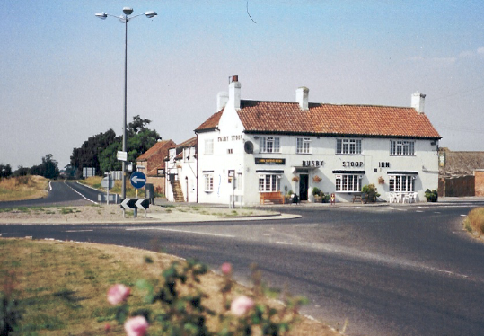
The Busby Stoop Inn, a well-known landmark, at the junction of the A61 Ripon-Thirsk road and the A167, at one time a branch of the Great North Road and for a brief period from 1922 the A1. The replica hangman’s noose can just be seen to the left of the building, by the fire escape.

The road curved round to the north and crossed Catton Moor, rejoining the route of the A167 at what later became Topcliffe Station, though the railway has once more disappeared. The straight road from Topcliffe, joined here, passes Alanbrooke Barracks, until 1972 RAF Topcliffe, which during the Second World War was home to squadrons of the Royal Canadian Air Force. From this junction the road ran due north to a cross roads, now a roundabout, by a pub and garage called the Busby Stoop. The pub sports a hangman's noose and Thoresby reports having seen the "doleful object of Mr Busby hanging in chains, for the murder of his father-in-law, Daniel Anty, formerly a Leeds clothier, who having too little honesty to balance his skill in engraving, &c. was generally suspected for coining, and other indirect ways of attaining that estate which was the occasion of his death, even within sight of his own house." Busby's father in law is usually reckoned to have been Dan Auty rather than Anty. His house is not within sight, but not far away; it is now a farmhouse near the village of Kirby Wiske, called Danotty Hall. Busby was hanged and gibbeted in 1702. The road continues past another disused airfield, also used by the RCAF during the War, through Sandhutton, where John Wesley preached, past Breckenbrough, where Roger Ascham, tutor to Queen Elizabeth I, was born in 1515, through Newsham, where there was a tollbar and the toll house is still standing, via South and North Otterington to the town of Northallerton.

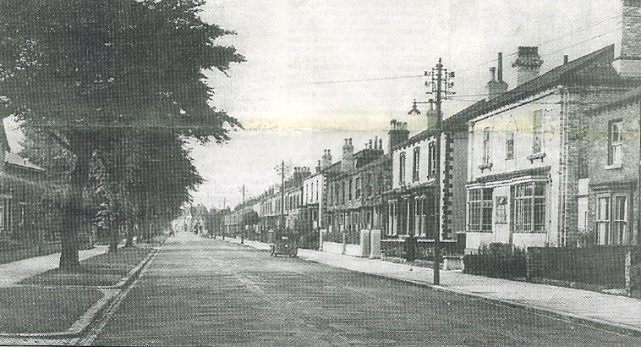
A pre-War photograph of South Parade, Northallerton, cut in the early 1800s to save coaches from the sharp bend at the Durham Ox. The white house on the right was destroyed by a bomb in May 1941.

As the road enters Northallerton, past the main line railway station, County Hall, built by Brierley in 1906 on the old racecourse, is on the right. The main road is now South Parade, which was cut in the early 1800s, when the galloping coaches found the right angle bend from the High Street by the Durham Ox too sharp to take at speed. This pub, one of 19 of its name, commemorates a famous beast bred in the closing years of the 18th Century by Charles Collings, which is the ancestor of the Shorthorn breed; at the time it was considered "so wonderful an animal and so far exceeding whatever had been seen before, that it was purchased to be exhibited" and spent the rest of its life touring the country in a specially built carriage; when the beast was killed at the age of 11 it weighed 165 stone 12lbs. Here, in Northallerton High Street, we rejoin the route through York.

Up means travelling towards London; Down away from London.
Fiennes p 102.
Known as “The Squire” to distinguish him from others of the same name, he did much to restore the family’s fortune which had been squandered by his father, also George Lane Fox, known as “The Gambler”.
Nikolaus Pevsner The Buildings of England: Yorkshire: The West Riding Penguin 1959.
Edward Mogg Paterson’s Roads 16th Edition 1822.
A Tour to the North 6 June 1792.
Ibid.
While most of the house is Victorian, the rotunda and stables are late 18th Century.
Fiennes pp 94-5.
Ralph Thoresby Diary 22 May 1703.
Ibid 17 May 1703.
Peter Ridley in the Darlington & Stockton Times, 24 December 1998.
E Bogg The Abbey Vale of Lower Yore Parker, Ripon 1909.
Leland.
Ralph Thoresby Diary 6 September 1681.
Sabine Baring-Gould Yorkshire Oddities, Incidents and Strange Events Methuen 1890. Baring-Gould was the author of the words of Onward Christian Soldiers.
See Part I Chapter 10.
Diary 17 May 1703.
Ibid.
Mike Bridgen writing in the Darlington & Stockton Times 24 May 1997.

