CHAPTER 8

York to Northallerton

The road proceeds down the street called Bootham, past Bootham School, run by the Quakers who were prominent here, and St Peter's School, founded in 627, where Guy Fawkes was a pupil. It continues through Clifton with its charming green, across the new bypass at Rawcliffe, past Skelton on a bypass dating from the turn of the 18th/19th Centuries. The13th Century church of St Giles in this village has been described by Pevsner as "an amazing building, quite small, but extremely ornate, and its internal scale such that one is tempted to regard it as the result of a reduction of the original intention." The stones of which it is built are said to have been left over from the building of York Minster. The road continues through Shipton by Beningbrough, close to the fine early Georgian house now owned by the National Trust, over the flat vale countryside to Easingwold. All the country between York and Easingwold was once the Forest of Galtres, which grew right up to the city walls and was a notorious haunt of robbers. At Tollerton lane end, the road until recently performed a right-angle turn to the left and again to the right around Fleet Bank Farm; its route can clearly be seen today. Leland mentioned the view of Crayke Castle from here, away to the north north west; King Egbert granted it to Saint Cuthbert and it remained until recently the property of the bishops of Durham. The castle, originally 15th Century but extended in the 19th, is now a private house. On the right of this stretch of road, after Shipton, is the Regional Seat of Government designed during the Cold War to protect a select few bureaucrats from the effects of a nuclear attack; it is at a farm called New Parks.

Easingwold, 13 miles on from Bootham Bar, was the next stage for coaches. There were two inns: the New Inn at which the Royal Mail and the Highflyer changed and the Rose & Crown, which horsed the Wellington and the Express. At the Rose & Crown there was a famous post boy, Tommy Hutchinson, who rode at seven stone and who once, during the Assizes, rode to York and back five times in a day, a distance of 130 miles, four of the journeys on a single mare. When coaching ended, he went back to being a tailor, his original trade. In the church there is a mid 17th Century parish coffin, one of only two remaining in England, which was used for paupers' burials and could be reused. Easingwold was bypassed in 1995 and the old road meets the new a mile beyond the town at a junction which was the scene of two fatal accidents soon after the opening of the bypass and which has now been replaced by a roundabout to meet much criticism.

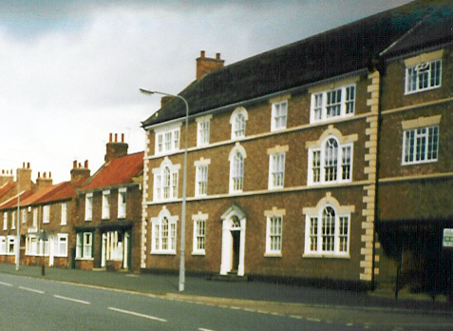
The former Rose & Crown, Easingwold.
.
As the village of Thormanby is approached, the Hambleton Hills can be seen to the right of the road, including the White Horse cut into the hillside above Kilburn. This was dug out under the direction of the village schoolmaster in 1857 and, as the soil is not chalky, needs regular attention to keep it white. In the village of Kilburn, Robert Thompson, the Mouse Man, made furniture and his successors continue to do so. In Thormanby, the Crown was owned by the firm of Cattle & Maddocks who ran the stables for the York Tavern; this was the end of their ground and here the Royal Mail and the fast coaches changed, while the slow coaches went on to Thirsk. The inhabitants of this small village resent its being divided by the busy main road and are campaigning for a bypass.

Three miles before Thirsk, the gates of Thirkleby Park are passed; the house, built in about 1785 by James Wyatt for Sir Thomas Frankland whose family had lived at Thirkleby since the 16th Century, was sold and demolished in 1927, leaving only the stable block. Before the Great Reform Act of 1832, the Franklands owned 49 of the 52 burgage houses in Old Thirsk, the occupiers of which elected two members of Parliament, so they effectively nominated both members. One of Sir Thomas's descendants who lived here was Sir Ralph Payne-Galway, a great Edwardian shot. Just beyond the gates is Griffin Farm, once an inn, where there was a turnpike gate.

As the road (the A19) enters Thirsk, it passes under the bypass, which takes over its number and goes on up through Teesside to the Tyne Tunnel. Thirsk according to Harper is "the sorriest and most commonplace of towns", but this is a minority view and it has become a centre for tourists visiting the Dales and Moors of North Yorkshire. Above all it has become the model for Darrowby, James Herriot's fictional town, largely because the author, whose real name was Alf Wight, lived and worked as a vet in the town from the 1940s until his death in 1995. His practice has recently moved from the old house in Kirkgate, now a Herriot museum, to new premises on the industrial estate beside the York road as it enters the town.

In the market square there are many old inns, as several cross routes passed through the town. The oldest is the Three Tuns, which from 1722 to 1773 was the manor house, but which was then kept in the coaching era by Mrs Alice Cass until 1815. At the beginning of the 19th Century, a traveller commented: "Thirsk…is a handsome town, but disgraced by a shabby range of buildings in the market place: rubbish surrounded by beauty. The situation is on the great road from London to the North, yet contains but one Inn for the reception of travellers; but it is an excellent one, though kept by a woman, Mrs Cass."

Here the London to Newcastle and London to Edinburgh coaches changed; so did the North Briton and the Defence, both Leeds to Newcastle coaches, which came up through Harrogate and Ripon. On her retirement Mrs Cass passed the business, except for the North Briton, to her relation, George Blyth, who had been running the Fleece, later Hall's Fleece and now the Golden Fleece. He enlarged the Three Tuns; making it the leading inn, with 50-60 horses in the stables. He ran the North Highflyer, which competed with the North Briton, and later took over some of the London coaches, including the Edinburgh Mail (from the Crown) and the Express, a London to Newcastle coach which was driven on the York to Darlington stretch by one eyed Peter Elliot, who had a team of "blind 'uns", four horses with only one good eye so that driver and team were said to have only one pair of eyes between them. Billy Baines was a postboy at the Fleece for 50 years.

In the market square, there are also the remains of the bull ring, a 30 foot circle in the cobbles where the buses park. This was where bulls were baited by terriers to tenderise the meat before being killed; in the 18th Century it was illegal to kill a bull unless it had been baited in the approved manner. Beside the bull ring is "a depressing Clock Towerette", set up in the 1890s to celebrate the wedding of the Duke of York to Princess Mary of Teck, who became King Edward VII and Queen Mary.

The castle in Thirsk stood to the west of the market place, near the present day fire station. The manor of Thirsk had been given by the Conqueror to one of his Norman barons, Roger de Mowbray, as part of the establishment of strong points to resist the Scots following the Harrying of the North and the depopulation that followed. The castle was demolished by Henry II in 1184 when another Roger de Mowbray, a crusader, became over-mighty. It was never rebuilt. The de Mowbray family, from which the Vale of Mowbray, stretching from the hills on both sides and from York to Darlington, took its name, owned the manor of Thirsk with extensive lands around until 1475, when the male line died out, and their descendants, the Stanleys, earls of Derby continued in possession until in 1722 they sold the manor to Ralph Bell, a former MP for Thirsk, for the huge sum of £6,300.
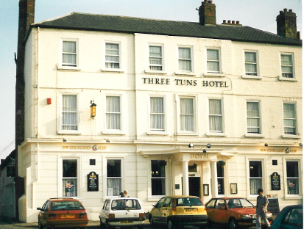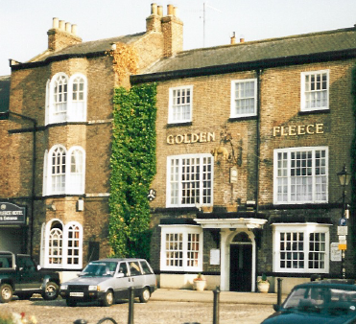

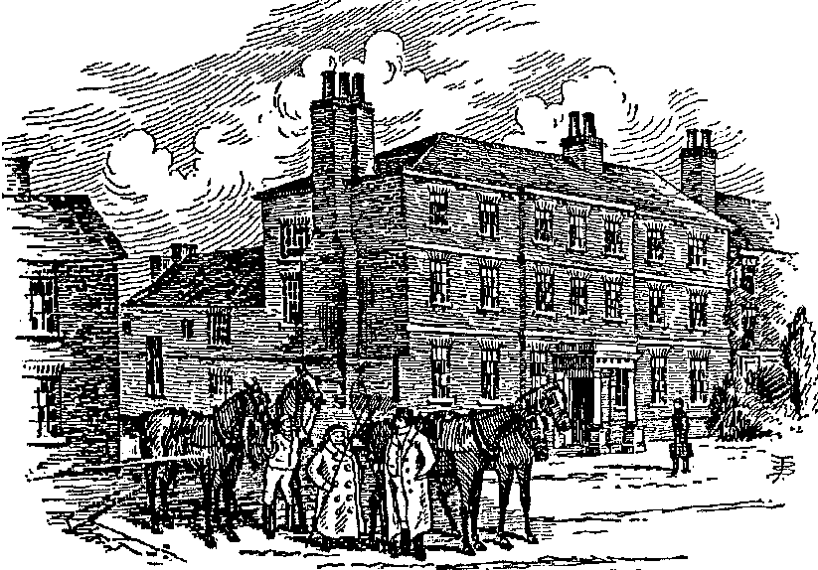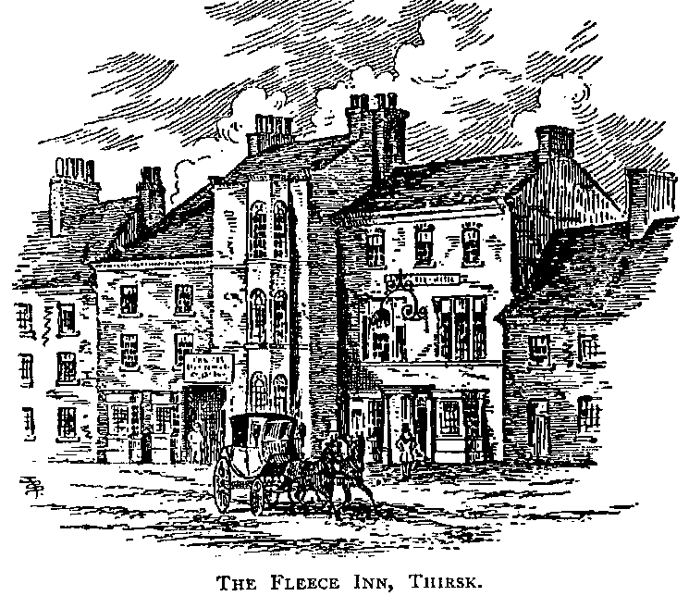
Two Thirsk inns, today and as pictured by Bradley at the end of the 19th Century.

As the road leaves the market square, it passes James Herriot's old surgery in Kirkgate on the left, nearly opposite the museum which was the birthplace of Thomas Lord, after whom Lord's Cricket Ground, home of the MCC, is named. Thirsk Hall faces on to the street just before the church; it was built in 1720-23 but extended in 1771 by the famous Yorkshire architect John Carr for the Bell family, the Squires of Thirsk, who preserved the cobbles in the square for so long. St Mary's church is beside the Hall and has been described by Pevsner as, without question, the most spectacular Perpendicular church in the North Riding. It was started, on the site of an older church, in 1430 and took 70 years to complete; it was restored by G E Street in 1876. To the right of the road can be seen the Cod Beck, a small tributary of the Swale.

About a mile north of Thirsk, on the right hand side of the road beside the beck, is Spa Farm, built on the site of an old saline mineral spring, the water of which was said to resemble that of Scarborough and Cheltenham and was used for bathing and drinking, to which many miraculous cures were attributed. It dried up in 1859, apparently because of the draining of nearby farmland.

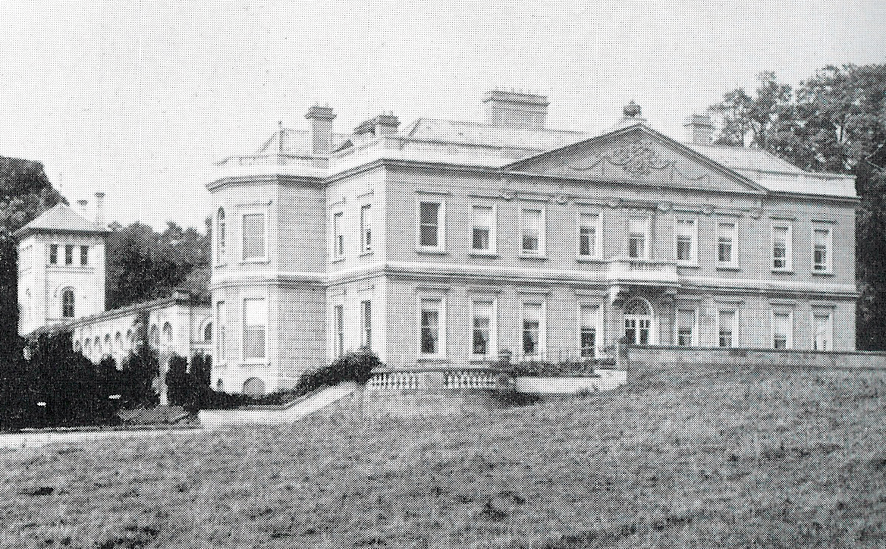
The house at Thornton Stud, then known as Wood End, which was broken up by the “Forty Thieves” in 1926. The stables behind are extant.

Thornton le Street was, as its name implies, on the Roman road. The Great North Road ran down the small lane, no longer passable, through the centre of the village past a former inn called the Spotted Dog, rejoining the present road (A168) just by the gates of Thornton Park. This stud was until 1995 owned by Lord Howard de Walden and his famous stallion Kris stood there for many years. There is no large house in the park; it was sold in 1921 to a syndicate of local farmers known as the Forty Thieves who demolished it and sold the materials, leaving only the18th Century stables. The two gatehouses on the main road, once described as the two most perfect classical boxes in England and by Pevsner as "a quite excellent late C18 job", are also still there. A little farther on, to the right of the road and hardly visible when the leaves are out, is Brawith Hall, a perfectly preserved Queen Anne house, according to Pevsner.

Bradley did not think much of this stretch of road, writing in 1889 as follows:

... the stages from Easingwold to Thirsk and Northallerton present but a poor, cramped appearance to-day, and have sadly deteriorated since the old coaching days. All along the road there is plenty of evidence of adjacent property owners having annexed the rich grass borders with which it was once margined, and nowhere is this so evident, perhaps, as along the stage lying between Thirsk and Northallerton, which is at once commonplace and unpicturesque, and when we look upon its narrow and confined irregularities of to-day we sigh for the grand old times when land grabbers troubled not, and there was plenty of room for two opposition coaches to race abreast without much fear of a collision.

Northallerton is the county town of England's largest county, North Yorkshire, and before that the North Riding, but it is really little more than a market town. Writing in the early 17th Century, William Camden said: "Northalverton a towne....where is nothing else but a long broad street, howbeit, having in it on St Bartholomewes day the greatest Faire of Kine and Oxen, and of the most resort, that ever I saw in my life." The original grant, for fairs on St Bartholomew's Day in September and Candlemas in February, was made by King John in 1200. Later grants were made for the St Matthew's Day and St George's Day fairs, but all these fairs were moved to the neighbouring town of Bedale in 1841.

The market is held on Wednesday and Saturday in the broad High Street, where the coaching inns were. The Golden Lion, the second of its name, is still prominent, and was the most important. In the coaching era it was kept by Godfrey Hirst and, after 1810, by his son Frank, who owned the ground between Thormanby and Enter Common to which we shall come presently. Here the Wellington, London and Newcastle coach, stopped. This famous coach made its last journey empty after the railway had taken its trade, driven by Thomas Layfield, a local man; he and others bought the ground between Newcastle and Edinburgh before the railway bridges were built at Newcastle and Berwick. Hirst had the monopoly of the posting business at Northallerton and, after his death in 1835, his trustees sold the business to Barber, Cattle & Maddocks of York, thus getting out of horses just in time. The Edinburgh Mail was horsed by Robert Smith at the Black Bull, which still stands in the High Street, though part of the original inn is now shops. So were The Hero, the Leeds and Newcastle night coach, and the Leeds and Newcastle Diligence, which left the Talbot, Leeds at 4 o'clock in the morning. This had a counterpart, called the Old Diligence which left the Star & Garter, Leeds at 4 o'clock in the afternoon and which, along with the Highflyer and the Express, changed at the King's Head, next door to the Black Bull, which has now disappeared completely.

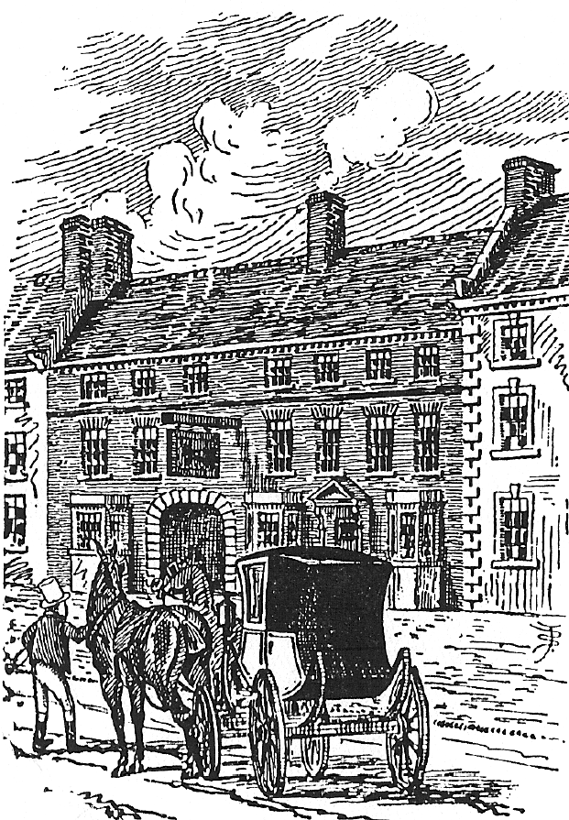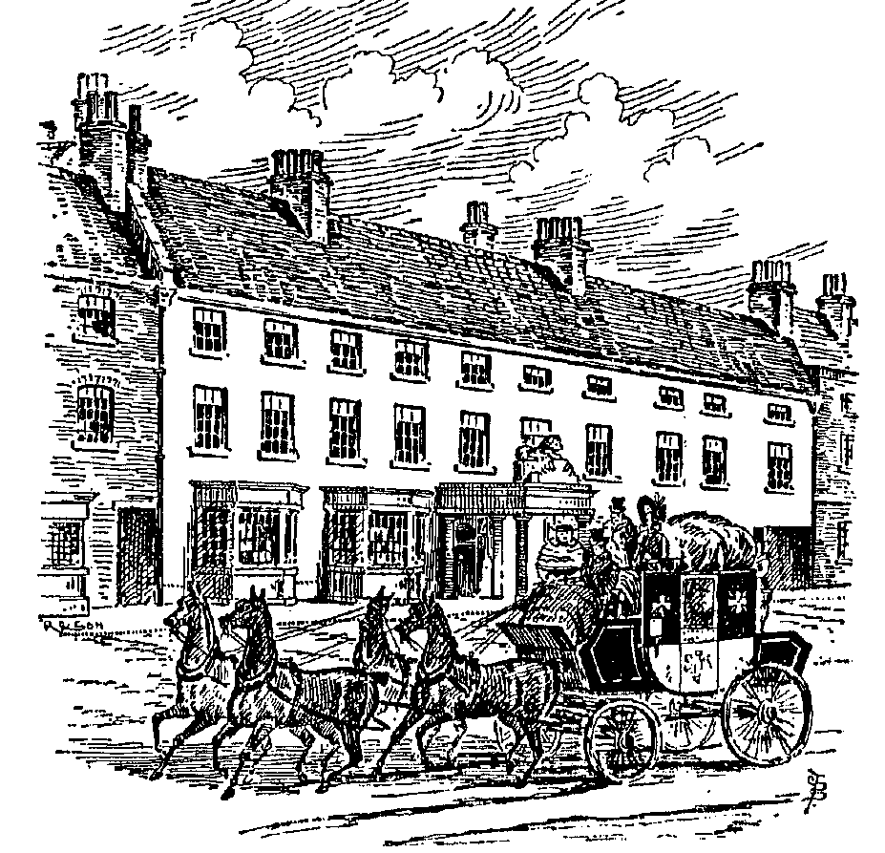

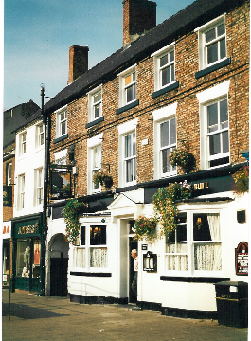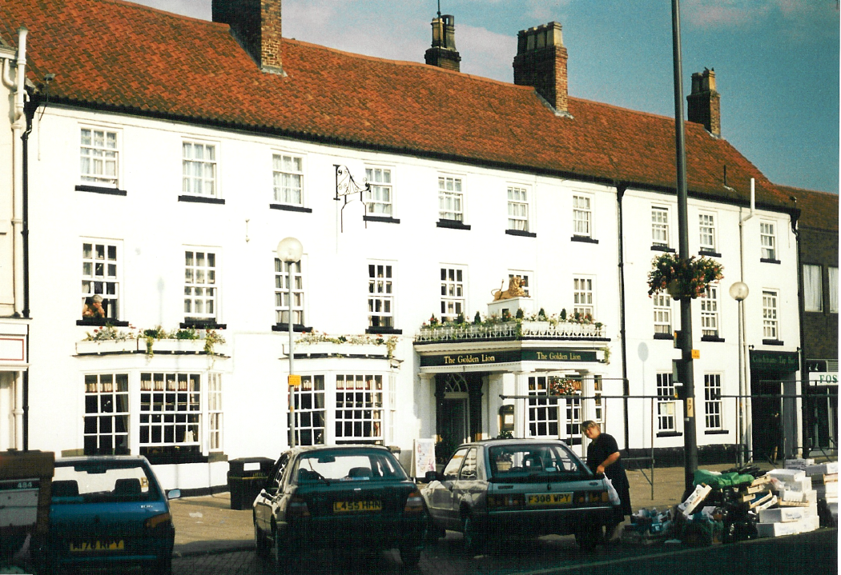
Two Northallerton inns, pictured by Bradley and recently. The Black Bull, on the left, horsed the Royal Mail, while the Golden Lion was owned by Frank Hirst who provided post horses between Thormanby, south of Thirsk, and Enter Common on the road to Darlington..

Northallerton suffered from being on the route south of the marauding Scots; it was plundered and burnt by them in 1319 on their way to York and the Battle of Myton and again in 1322. Some of the leaders of the Pilgrimage of Grace were executed outside the church. Henry VII's daughter, Margaret, stayed a night here on her journey to be married to James IV of Scotland. Charles I was held prisoner here in 1647 by the Scots, to whom he had surrendered the previous year, by legend in Porch House opposite the church. Leland was disappointed not to find any noblemen's tombs in the church, even though it dates from the 12th Century.

Quakers were responsible for the chocolate manufacturing companies of York, notably Rowntrees and Terrys.
Nikolaus Pevsner The Buildings of England: Yorkshire: The North Riding Penguin 1966.
Even after the 1832 Reform Act extended the franchise to £10 householders and widened the boundaries of the constituency, there were only 254 electors – but the number of MPs they elected was reduced to one, initially Sir Thomas Frankland.
William Hutton 1723-1815 Trip to Coatham 1808.
Pevsner Op cit.
William Camden Britannia.

