CHAPTER 7

Doncaster to York by the Eastern Route

This part of the route is the most complex, with many variations having been used at different times and even by different coaches at the same time. We saw in Part One that up to the end of the 17th Century the mail, then carried by a postboy, had taken the Wetherby and Boroughbridge road, missing York out altogether. Then it began to go through York, turning off after Ferrybridge at Brotherton and going via Tadcaster, and it continued on this route, with some variations, until 1758 when, under pressure from Edinburgh merchants, York was again bypassed and the mail went back to the old route in order to save time. Some travellers continued to go through York and Armstrong's Survey in 1783 gave both of the alternatives. When the Royal Mail was first carried by coach, it went initially to York and was there transferred to another coach for the rest of the journey to Scotland, and the through coach, established in October 1786, kept to that route in the early years. Towards the end of the coaching era, competition led to the Mail on the York branch going via Selby to save three miles, which became possible when the Doncaster to Selby Turnpike Act was passed in 1832 and a new road was built on a new route - there is no sign of a through road along that line on Thomas Jefferys's 1771 map of Yorkshire.

The present route of the A1 via Ferrybridge and Wetherby to Darlington was still commonly used by stage-coaches going further north, but the Selby to York route, once established in the 1830s, never ceased to be regarded as the Great North Road until the railways took over and was used by the Mails; Harper gave both the Selby and the Wetherby branches when he wrote in 1901. When road numbering was first introduced in 1922 the A1 was designated as the road via Ferrybridge, Boroughbridge, Topcliffe, Northallerton and Croft on Tees to Darlington, though two years later it was changed to the present route from Boroughbridge to Scotch Corner. Yet, in 1955, one author was still giving two alternatives: Ferrybridge - Wetherby - Boroughbridge - Scotch Corner, which was of course the A1, and Selby - York - Thirsk - Northallerton, the A19 and A167. As late as 1961, Morley gives the route as Doncaster, Selby, York, Northallerton, Croft on Tees, Darlington. This is all very confusing but, as we have been following Harper's route so far, we shall continue to do so here; first we shall go by way of Selby and York and then we shall take the Ferrybridge road with its variations.

The road from Doncaster left by Frenchgate and crossed the river Don by a new bridge replacing the one on which Robert Aske met the Duke of Norfolk during the Pilgrimage of Grace in 1536 and negotiated all day to reach a settlement. The railway line is also crossed nowadays and the station and wagon works can be seen to the left. At the present roundabout at the far end of the bridge, we fork right and follow the A19 through two former mining villages, Bentley and - once a spa too - Askerne. The next 13 miles are dull and featureless, apart from the cooling towers of the many power stations to be seen standing up in the plain. The road crosses the M62 motorway and the Aire and Calder Navigation at Whitley Bridge, the River Aire at Chapel Haddlesey, and the Selby canal just before Brayton where there once was a tollbar. Brayton, which Harper describes as "about as miserable a hole as it is possible to find in all Yorkshire", is now almost part of Selby. It is partly redeemed by its church, by the side of the road, which has a Perpendicular spire resting on an octagonal lantern, the whole standing on a Norman tower. The lantern is purely practical and provided a beacon for those crossing the flat marshes by night.

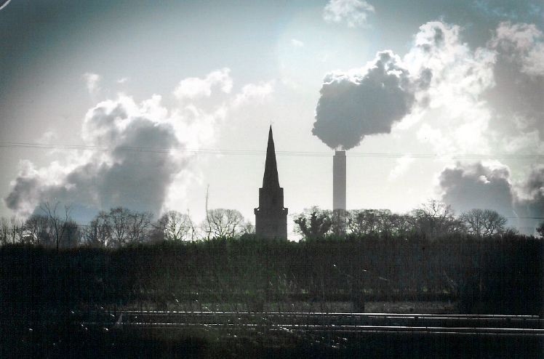
St Wilfrid’s Church, Brayton, and smoke and steam from the Drax power station.
(Yorkshire Post 2 April 2001)
Selby, on the River Ouse, once a major seaport and centre for the flax and wool trade, is dominated by its magnificent Abbey, which stands in the market place. The town was a centre of activity during the Civil War, including a battle fought in 1644 in and around the town, won by the Parliamentary forces under the Fairfaxes, father and son, immediately before the bloody and, as far as the North is concerned, decisive Battle of Marston Moor. The Abbey, founded in 1069 by the Benedictines, became the parish church in 1618, nearly collapsed shortly afterwards and was stripped of its treasures and used as stables by the Parliamentary army after their victory here. Its nave is Norman, with solid stone piers reminscent of Durham Cathedral; the north porch Transitional; the choir and Lady Chapel including the fine east window depicting a Jesse tree Decorated; and the west front an amalgam of Norman, Early English and Decorated with a Perpendicular window inserted. The Abbey was badly damaged by a fire in 1906, which melted the bells, but has been well restored, so well indeed that Jenkins awards it five stars and describes it thus "Selby's [glory] is that of a stately old lady, retired to the country with her dignity and memories intact.”. In front of it stands the market cross, built on the site of an older one in 1775 by the lords of the manor, the Petre family. The coaching inns were Rose & Crown in New Street, still there but in a dilapidated state, the Petre Arms, which became the Londesborough Arms when the manor changed hands in 1854, and the Swan in Ousegate, no longer to be found.
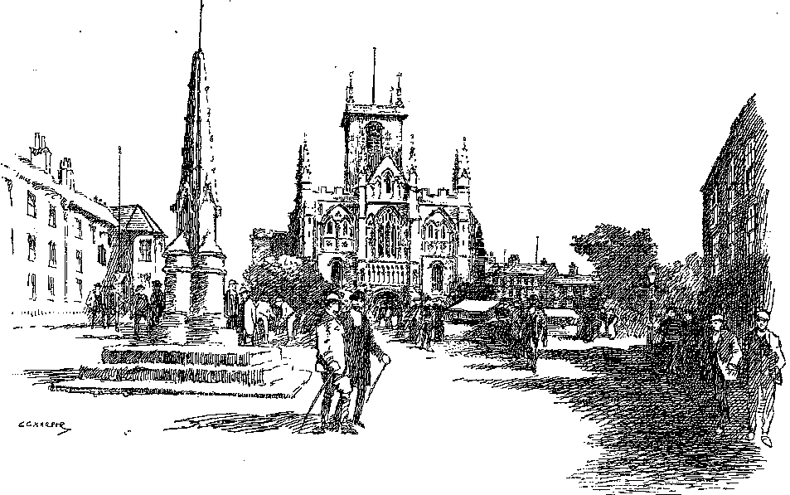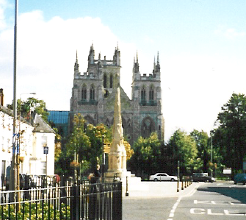
Selby Market Place and Abbey, on the left drawn by Harper in 1901 before the fire of 1906, and on the right in modern times when the west towers had been added. The Londesborough Arms is on the left in both pictures.

The road continues over a narrow swing bridge, where until 1991 a toll was charged, built between 1791 and 1797 to replace a ferry, and passes a line of feed mills. In the 1830s when the Mails began using this route again they were given precedence over vessels on the Ouse and the swing bridge had to be kept open for road traffic for two periods of half an hour a day. The road then runs parallel to the railway line which was until the 1980s the main line, before it was diverted to the west of the town to avoid the new coal mines developed to exploit the Selby seam. The villages of Barlby and Riccall, bypassed in 1987, are unremarkable, although it was at Riccall that Harald Hardrada tied his ships up when he invaded in 1066. The next village is Escrick and on the right are the gates of Escrick Park, now a girls' school, at which Tom Holtby was intercepted on his last drive of the Edinburgh mail in 1842.

The road passes under the modern York bypass, through the suburb of Fulford, past the barracks and into York by way of Fishergate, over the River Foss at Castle Mills Bridge, past the castle and round Clifford's Tower by the modern Tower Street, formerly called Castlegate Postern Lane, and sharp left into Castlegate. The more direct road via Clifford Street was not cut until after the coaching era. The castle, once a prison, now houses the Courts and a museum. The surviving Clifford's Tower was built in the 13th Century and is not the one in which, on the night of 16th March 1190, 150 Jews and Jewesses of York took their own lives rather than submit to a crazed mob. In Castlegate the road passed Fairfax House, built by John Carr 1755-62 for Viscount Fairfax of Elmley and St Mary’s church which now houses a dinosaur exhibition. The Friends’ Meeting house down an alley to the left was there when Jefferys made his map in 1771. From here the road ran into Nessgate and then, past St Michael’s church beside Ouse Bridge, into Spurriergate which becomes Coney Street after a few yards Coney Street, where the main inns were.

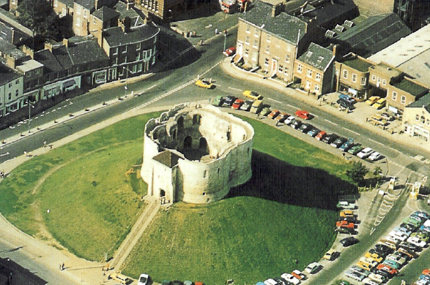
The 13th Century Clifford’s Tower, built on the site of the one in which the Jews perished in 1190.

None of the old coaching inns is extant, even those mentioned by Harper in 1921. The most prominent inn was probably the Black Swan in Coney Street, its building now occupied by BhS. It opened in 1698 and at its height had 150 horses in its stables; it was still going in 1842 when the coaches stopped. Here the London and Edinburgh Mail, the Highflyer and the Wellington (both London to Newcastle coaches), the Express (London to Carlisle) and many coaches on cross routes to Scarborough, Hull, Harrogate and Helmsley were changed; at one time 60 coaches a day stopped here. The York Tavern in St Helen's Square, which later became Harker's Hotel and was later still demolished, was where the mails were generally changed and it too had well over 100 horses in its stables, operated by the partnership of Cattle & Maddocks. The building in St Helen's Square today called Harker's Cafe Bar is not on the same site; the York Tavern was on the other side, behind what is now Edinburgh Woollen Mills and Betty's tea rooms. It was conveniently close to the Post Office at the eastern end of Lendal, which is there to this day. The George in Coney Street, also no longer there, did no coaches but provided post horses for riders and stood opposite the Black Swan. This is where Byng stayed in 1792, recording his impressions:

Leading my mare over the stones, and over Ouze Bridge, I soon came to the George in Coney Street, which inn is one of these very old houses whose front is adorn'd by stucco'd imagery, and it is a very grand appartment with much carved work, and stained glass in the windows. My landlord said that our house was formerly a mansion of the Duke of Buckingham.

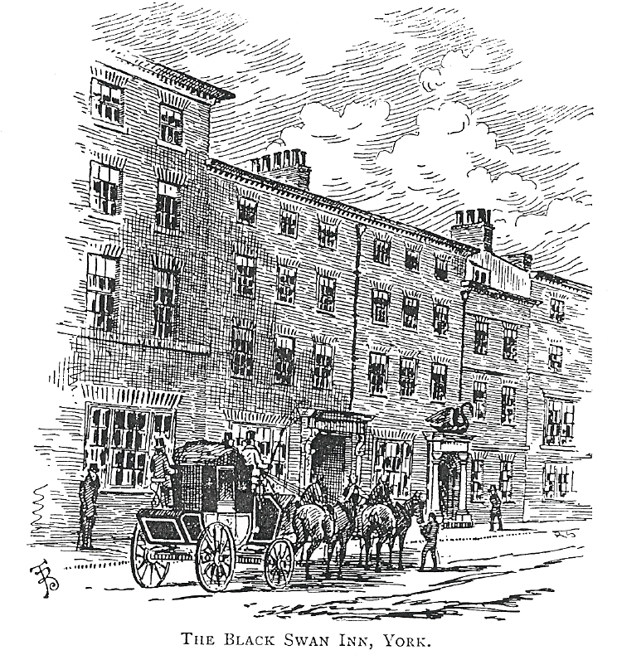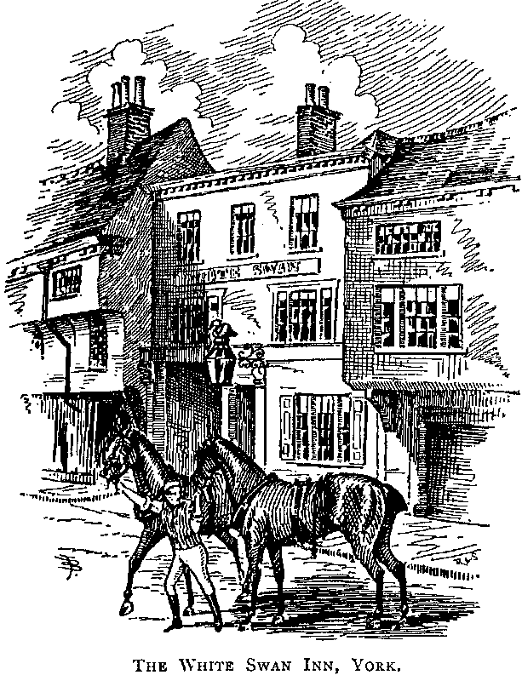
Two famous York inns, from Bradley’s book. The Black Swan in Coney Street horsed many coaches including the London and Edinburgh Mails. The upper floors of the inn can still discerned above the shop fronts. The White Swan in Pavement has completely disappeared.

Etteridge's Hotel in Lendal, also now demolished, retained 40 horses for the exclusive use of the nobility and gentry; Tommy Etteridge himself weighed 24 stone and drove round the city every day in a high gig. Two buildings of note in the area which do survive are the Mansion House, the Lord Mayor's residence, built 1725-30, on the southern side of St Helen's Square, and the rebuilt remains of the bombed church of St Martin le Grand, with its clock hanging over Coney Street dating from 1668. Other coaching inns in York included the White Horse opposite All Saints’ church in Coppergate, its site now Coppergate Walk - this horsed the York-Harrogate Integrity and the York-Newcastle Pledge - the White Swan in, which stood roughly where Piccadilly now meets Pavement, and the Elephant & Castle in Skeldergate on the other side of the River Ouse.

St Martin is just one of several churches in the city, which, in Simon Jenkins’s view is the finest set of medieval town churches in England. He continues “Though much damaged by time and war, they remain a wonderful complement to York Minster, evoking some sense of an English city in the late Middle Ages, each neighbourhood owing allegiance to an often tiny place of worship, enclosed by lanes and alleys.”

York reached the summit of its importance in the 250 years after 1200. Encircled by defensive walls during the Scottish wars, it became the seat of royal government when the focus was in the north of the kingdom. It was also a major trading centre, a port on the Ouse, exporting wool and cloth to the Continent and importing many minerals, wines and foodstuffs. Until the Industrial Revolution of the late 18th and early 19th Centuries, York remained by far the most important city in the north.

On leaving York, the coaches went from St Helen's Square down Blake Street and Lob Lane (now Duncombe Place) and High Petergate through Bootham Bar, which originally had a barbican on the outer side, taken down in the early part of the 19th Century. Demolished too was the city wall between Bootham Bar and the river, where once great chains hung across the water from towers on each side to prevent a water borne attack. The defences were tried and found effective in 1319 when the Scots came to York's gates.

In Blake Street the coaches passed the Assembly Rooms, which are now much admired but which were considered outrageously modern by many observers, including Byng, who wrote: "I went to view the Assembly Room built from a plan of Ld. Burlington's, who was surely the most tasteless Vitruvius? and has left the saddest Egyptian Halls and woeful walls to record his invention!"

The Rooms, financed by public subscription in 1730 and built by Burlington in Palladian style with Egyptian decoration, were rather a disaster when they opened in the 1736. Here is John Julius Norwich's verdict:

He turned to Palladio, and found his version of a design by Vitruvius for what he called - heaven knows why - an "Egyptian Hall", and described as being "particularly suited for festivals and entertainments". It never seems to have struck him that sixteenth-century Venetians - let alone first-century Romans - should have taken their pleasures somewhat differently than did the citizens of York in his own day; or that the latter should be rather more cumbersomely dressed. The result was the most severely classical building of the early eighteenth century in all Europe - but it was hardly festive, and very far from practical. The side aisles were too narrow to sit out in; the distance between the columns was fixed, with Palladian precision, to just double their diameter, so that couples sitting behind them either felt caged in or else invisible.

The Assembly Rooms now house a restaurant.

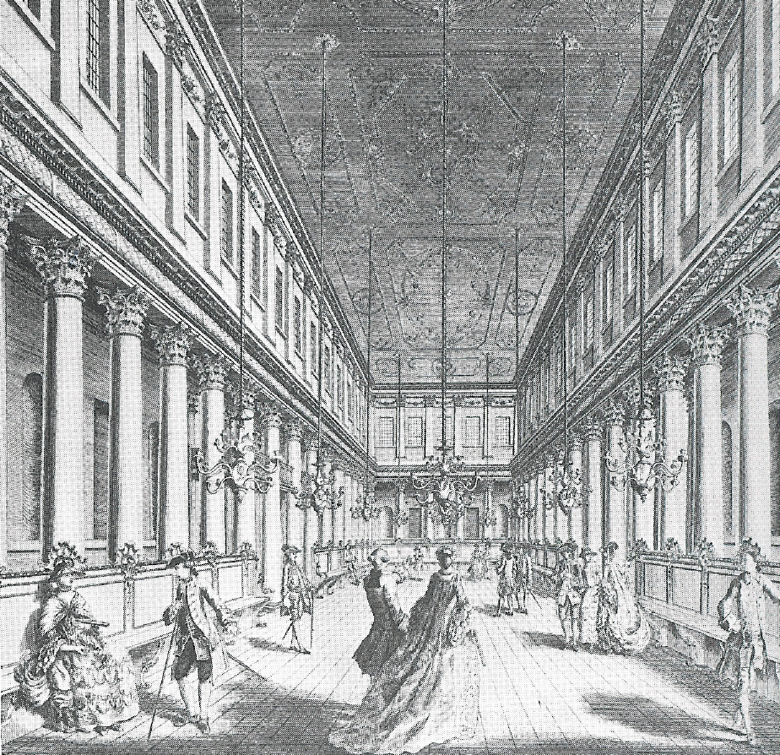
Burlington’s Assembly Rooms, York. (City of York Art Gallery)

Coaches passed the west front of the magnificent minster as they left. Although it was never a monastic church, it has been known as a minster since time immemorial; it was founded in 627 by Edwin, King of Northumbria. It is the fifth church to stand on the site and is the seat of the Primate of England, the Archbishop of York. The earliest parts are the transepts, which were built in the 13th Century. One of its most famous features is the 16th Century rose window in the south transept. This was completely restored following the fire of 9 July 1984, which was the third such fire that has afflicted the building, the previous ones being in 1829 and 1840.

Leland, writing in the 16th Century, says that the route from Ferrybridge to York went via Cawood, well to the east of any other route. Almost certainly this route was chosen to avoid flooded or marshy land.
M J Armstrong An Actual Survey of the Great Post Roads between London and Edinburgh London Third Edition 1783.
Christopher Trent Motorists’ Companion on the Highways of England. George Newnes Ltd, London , 1955. Trent also gives the Newark - Ollerton – Worksop – Doncaster route as an alternative to Retford and Bawtry.
Frank Morley The Great North Road Hutchinson 1961.
On this occasion Aske was well received by Henry VIII when he went on to London, but he was subsequently captured, tried at Westminster and put to death in York in 1537.
This canal, also known as the Haddlesey Canal, opened in 1778, linked the Ouse with the Aire, and was an attempt by the merchants of Selby to retain their trade, which had begun to be diverted by the Aire and Calder Navigation. Any respite was short lived for, in 1820, the Aire and Calder Navigation Company began to dig a new cut from Knottingley to Goole and much trade was subsequently lost by Selby.
See Part I Chapter 9..
A Tour to the North 4 June 1792.
This mediaeval church was all but destroyed by incendiary bombs in 1942, but has been partially restored. The clock and the stained glass had been taken down during the War.
These chains were observed by John Leland in 1534, as he travelled around the country preparing his topography. In Portrait of York (Robert Hale, London, 1972) Ronald Willis says these chains were to stop ships slipping away without paying quayage. On the southern side of the river, a gap was made in the medieval walls in 1841 to allow trains to reach the first railway station which was built within the walls south of Lendal Bridge, roughly where the railway company offices are today.
A Tour to the North 5 June 1792. Richard Boyle, Earl of Burlington was one of the foremost exponents of the Palladian style of architecture, inspired by the Roman, Marcus Vitruvius Pollio, and given much impetus by the publication in 1717 of Vitruvius Brittanicus by Colen Campbell, which made the work of the Italian architect, Palladio, the pattern for much 18th Century building. Burlington built the English nonpareil of this style at Chiswick House.
John Julius Norwich A Sense of Proportion from Spirit of the Age, a BBC2 television series, broadcast in 1975.
The last fire took place as a result of a lightning strike two days after the enthronement of the new Bishop of Durham, who had expressed controversial views on some fundamental church doctrines; some people regarded the fire as a sign of divine displeasure.

