CHAPTER 11

Northallerton to Darlington

Two miles from the outskirts of Northallerton, the field of the Battle of the Standard, marked by an obelisk to the right of the road, is reached. Here on 22 August 1138, Archbishop Thurstan of York’s makeshift army routed the Scots in the space of only two hours. Many Scots were killed in the surrounding countryside over the next few days and many more starved to death as they fled north. The Standard was a great ship's mast carried on a waggon surmounted by a pyx containing the Host and displaying the banners of northern saints, Saint John of Beverley, Saint Wilfrid of Ripon, Saint Cuthbert of Durham and Saint Peter of York. The road continues, past Lovesome Hill where there was a tollbar and where, before the cutting was dug, the road used to brush the doors of the cottages on the left of the road, northwards to Great Smeaton, having crossed the hardly noticeable River Wiske at Little Smeaton. Great Smeaton church is dedicated, uniquely, to St Eloy. Smeaton Manor, down the side road to the left at the end of the village, was built for Gertrude Bell's sister by Philip Webb in the 1870s, but its interior has been much altered by later owners.
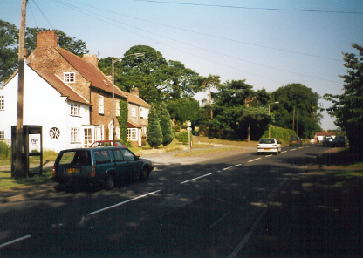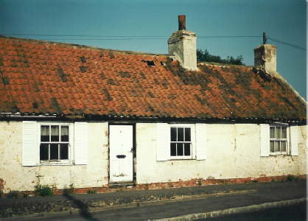
On the left, the road at Great Smeaton, with a row of cottages that used to be the Blacksmith’s Arms, where the Royal Mail changed horses when speed became all-important. On the right is the former tollhouse at High Entercommon.

The mails, which needed to travel fast, changed horses here at the Blacksmith's Arms, now cottages, but most of the coaches did the 16 miles from Northallerton to Darlington in one stage. At High Entercommon, less than a mile farther on, where the Yarm road forks off, there was another tollbar, and the tollhouse can still be distinguished at the garage of that name, though the Golden Lion, where towards the end of the coaching era the fast coaches changed, has disappeared; the inn-keeper here was William Thompson, formerly coachman to the landowner and amateur driver, Sir Bellingham Graham, who had sponsored J F Herring's early equestrian paintings.

A few hundred yards farther on, at Low Entercommon, where the existing road sweeps round to the left, the early road continued due north past Break House Farm, skirted the Tees to the east of Eryholme, went straight across the promontory, crossed the river by ferry to the west of Neasham, and thence ran north west to Darlington, entering by Neasham Road. This road was shown in Ogilby’s map of 1675 but was probably replaced by the Dalton-Croft road when the new Croft bridge was built in 1676.

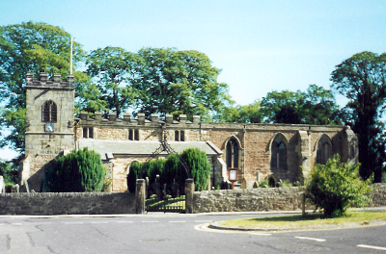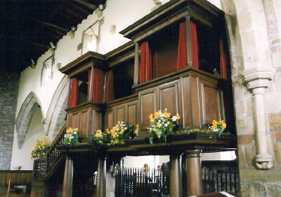
The church at Croft-on-Tees, where Lewis Carroll’s father was rector, and the Milbanke family pew, in which Annabella, Byron’s wife, sat.

The winding road originally passed through Dalton on Tees, its meanderings still to be seen to the left of the road, before coming to Croft, where Yorkshire ends. On the Durham side the village is called Hurworth Place. On the left before the bridge, according to Harper, the "mouldy-looking Croft Spa Hotel fronts the road"; it has been refurbished since then. The church, where Lewis Carroll's father was rector, is well worth a stop, for it contains an astonishing family pew once belonging to the Milbanke family, who lived at nearby Halnaby Hall (demolished 1952), and some ancient tombs of Milbankes and another local family, the Clervaux of Clervaux Castle (which was pulled down in 1950). The Clervaux were succeeded by the Chaytor family who still live at Croft, and one of whom, Sir William Chaytor, spent the last 21 years of his life (1700-21) in the Fleet prison in London, where he was consigned for debt and where he lived fairly comfortably, corresponding widely and continuing to run his estate through his agent. The 1676 bridge over the Tees replaced an earlier one. The Comet inn in Hurworth Place was there when Harper sketched the village in 1901.

Croft is also significant in railway history, for it was here that the York to Newcastle line began to be built in 1837, eventually connecting Newcastle, or rather Gateshead for the Tyne was not bridged for some years, with London. The railway bridge is just before the village approaching from the south.

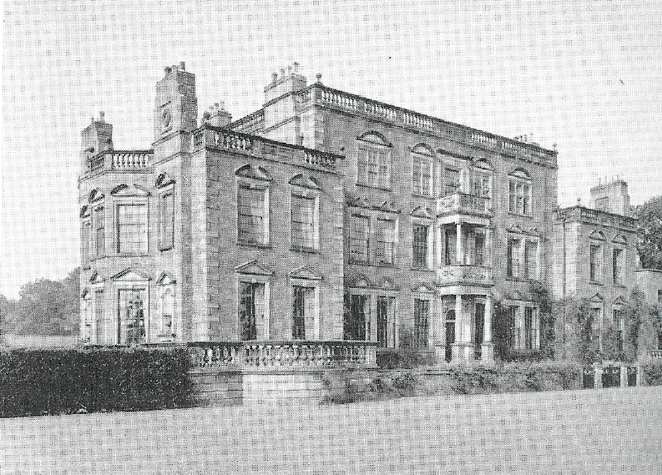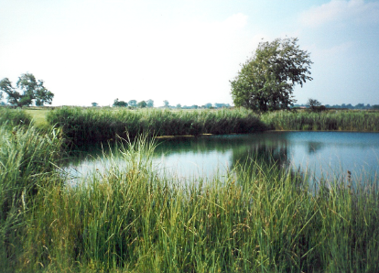
Halnaby Hall, demolished 1952, Annabella Milbanke’s home. On the right, one of the ponds known as Hell’s Kettles, observed by Celia Fiennes and Daniel Defoe.

A little farther on the road crosses the tiny River Skerne and just there on the right are Hell's Kettles, some deep ponds, which were once considered one of the sights of the area. Celia Fiennes had this to say:

Two miles from Darlington I came to the ground the Hell Kettles are they talk much off, its in grounds just by the road where cattle were feeding; there are 2 pooles or ponds of water the one larger than the other the biggest seemed to me not to be the deepest nor is it esteemed soe deep; there was some sedge or flaggs growing round that, but the farthermost which was not soe bigg looked a cross that had noe flaggs or sedge on its bancks, but yet it look'd to me to cast a green hew, roleing waves of the water just in collour of the sea, and as the wind moved the water it very much resembled the sea, but the water when taken up in the hand look'd white and the taste was not the least brackish but fresh; my conception of the cause of the greenish collour was from the greate depth of water, for the reason they call them Hell Kettles is that there is no sounding a bottom which has been try'd by plumet and line severall fathoms down; the water is cold and as any other water when took up, it seemes not to decrease in a tyme of drought nor to advance with the great raines, it draines it self insensibly into the ground.

Leland reported that local people thought there was an underground passage linking the pools to the river Tees, as some ducks had been seen to disappear in the ponds and to pop up again near Croft bridge. Daniel Defoe was less impressed. He said " 'Tis evident, they are nothing but old coal pits filled with water by the River Tees."

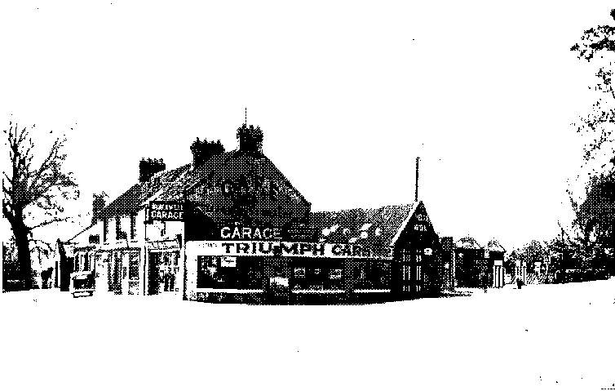
Bland’s Corner, where the Northallerton road (to the left) meets the road dfrom Scotch Corner (on the right), to the south west of Darlington. There is still a garage there and also a large roundabout.

The road meets a new bypass at Bland’s Corner or the Blackwell roundabout, where the road from Scotch Corner rejoins the main route. Blackwell Grange to the left of the road after the roundabout, now a hotel, was the home of the descendants of Sir Henry Havelock, the General who relieved Lucknow in the Indian Mutiny and whose equestrian statue stands on a plinth in Trafalgar Square. We are now on the outskirts of Darlington, a railway town that has seen better times, though it must have seen worse times too for both King James I and Defoe commented on its dirtiness. The road here is the A66 as well as the A167 and follows Grange Road to the inner ring road. The old road went hence via Blackwell Gate into High Row, opposite the covered market. None of the old inns in the town centre survives and it is impossible to identify Scott’s Black Bear, where Frank Osbaldistone met the incognito Rob Roy for the first time. The most distinguished building in High Row is Barclays Bank, once the head office of Jonathan Backhouse & Co. The grandson of the founder, also Jonathan, achieved fame in 1819 when he drove to London and back in a post-chaise to fetch gold to meet a demand by the Earl of Darlington, who had tried to break the bank by accumulating its notes and then suddenly presenting them for payment in cash; in spite of a wheel falling off his post-chaise at Croft on the return journey, he completed it on three wheels by piling the gold into the opposite corner. Behind the Market Place is the late 12th Century St Cuthbert's Church, the tower of which was restored by George Gilbert Scott but which otherwise survived the Victorian era unimproved. It is perhaps the one building of antiquity and interest in the town.

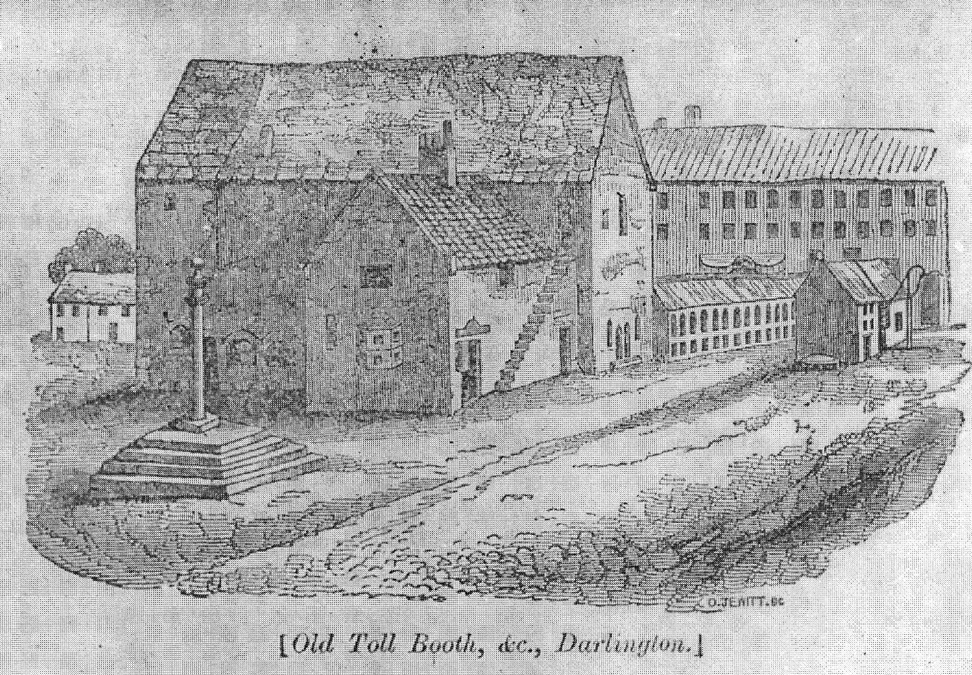
The Old Toll Booth, High Row,Darlington, with the market place behind. It was demolished in 1808 and the famous clock tower now stands on the site.

Darlington's chief claim to fame is being one end of the Stockton and Darlington Railway. The first engine, Locomotion, is displayed at the Railway Museum at the old Northgate Station. It became an important railway town but before that its chief trade was the bleaching of linen, for much flax was grown in the countryside round here.

Peter Ridley writing in the Darlington & Stockton Times 24 December 1998.
See Part II Chapter 6.
See Part II Chapter 12.
See Part I Chapter 10.
Fiennes p 180.

